

(**A Constituent College of Somaiya Vidyavihar University**)

# Batch: *A-4* Roll No.: *16010422211* Experiment No.: *03*

**Aim:** To implement database for relational model in experiment no. 2 using DDL statements (Virtual Lab).



**Resources needed:** PostgreSQL PgAdmin3



# Theory:

The Data Definition Language (DDL) is used to create and modify the relational schema. Also it is used to add various constraints to the table like the primary key, foreign key, check constraint, not null constraint and unique constraint.

The DDL statements are: CREATE

DROP ALTER

PostgreSQL supports the standard SQL types int, smallint, real, double precision, char(N), varchar(N), date, time, timestamp, and interval for creating tables.

# Procedure:

**Create Database and use it:**

$ createdb mydb

$ psql mydb

**Delete a database:** $ dropdb mydb

# Create table:

CREATE TABLE my_first_table ( first_column text,

second_column integer

);

CREATE TABLE products ( product_no integer,

name text, price numeric);

# Drop Table:

DROP TABLE my_first_table; DROP TABLE products;

# Default Value:

CREATE TABLE products ( product_no integer,

name text,

price numeric **DEFAULT 9.99** );

# Constraints:

1. **Primary Key**

CREATE TABLE products ( product_no integer **PRIMARY KEY**, name text,

price numeric );

Primary keys can also constrain more than one column. CREATE TABLE example (

a integer, b integer, c integer,

# PRIMARY KEY (a, c)

);

# Check Constraint

CREATE TABLE products ( product_no integer,

name text,

price numeric **CHECK (price** > **0)** );

# Not Null Constraint

CREATE TABLE products ( product_no integer **NOT NULL**, name text **NOT NULL**,

price numeric );

1. **Unique Constraint** CREATE TABLE products ( product_no integer **UNIQUE**,

name text,

price numeric );

# Foreign Key Constarint

CREATE TABLE products ( product_no integer PRIMARY KEY, name text,

price numeric );

CREATE TABLE orders ( order_id integer PRIMARY KEY,

product_no integer **REFERENCES products (product_no)**, quantity integer );

Here a foreign key constraint in the order table references the products table.

# Modifying table:

**Adding column**

ALTER TABLE products ADD COLUMN description text;

# Removing column

ALTER TABLE products DROP COLUMN description;

# Adding Constraint

ALTER TABLE products ADD CONSTRAINT some_name UNIQUE (product_no); ALTER TABLE products ADD FOREIGN KEY (product_group_id) REFERENCES product_groups;

# Removing Constraint

ALTER TABLE products DROP CONSTRAINT some_name;

# Adding Not Null Constraint

ALTER TABLE products ALTER COLUMN product_no SET NOT NULL;

# Removing Not Null Constraint

ALTER TABLE products ALTER COLUMN product_no DROP NOT NULL;



# Results: (Queries printout with output)

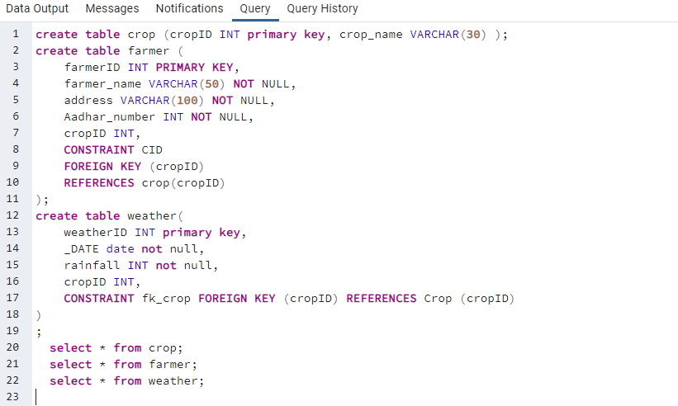

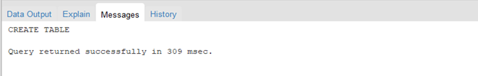

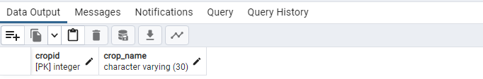

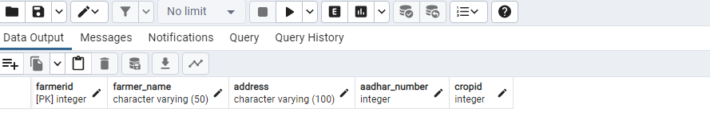

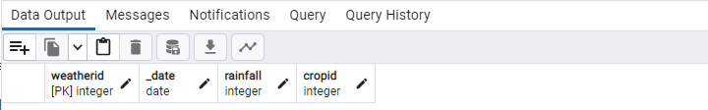

*MODIFYING TABLE:*

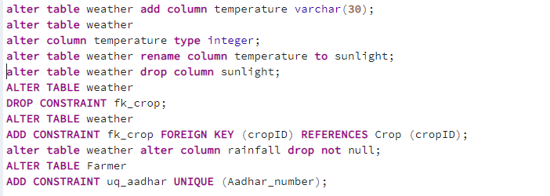

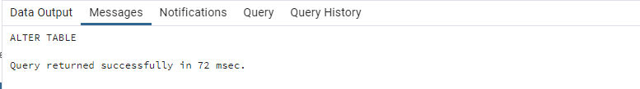



**Outcomes:**

CO: Illustrate the concept of Query Processing.



**Question:**

**Q1 what is difference between Truncate, Drop and delete? Explain with example**

*TRUNCATE:*

*Truncate is to remove all the rows from the table. It only removes the data from the rows and the column, constraints etc remains intact. It’s a DDL command, not available for all the database systems. EX: If we want to truncate farmer table, it removes the farmer record but the column, constraints remain intact.*

*DROP:*

*Drop is used to remove database objects such as tables, views or indexes. Dropping a table is deleting the entire table structure, including all data and related objects. EX: If we want to drop the farmer table it will remove the entire table structure.*

*DELETE:*

*Delete is used to remove specific row or record while preserving the table structure. It’s a DML operation. EX: If I want to delete farmer address, it will remove that specific row from the farmer table.*



**Conclusion:** *Learnt how to use PostgreSQL PgAdmin to implement database for relational model in expt no. 2 using DDL statements.*

**Grade: AA / AB / BB / BC / CC / CD /DD Signature of faculty in-charge with date**

**Reference books:**

(Autonomou of Mumbai)

1. Elmasri and Navathe, “Fundamentals of Database Systems”, 6th Edition, Pearson Education
2. Korth, Slberchatz,Sudarshan, :”Database System Concepts”, 6th Edition, McGraw – Hill.

# WebSite:

1. <http://www.tutorialspoint.com/postgresql/>
2. <http://sage.virtual-labs.ac.in/home/pub/21/>

(Autonomous College Affiliated to University of Mumbai)